NPCC 301 Lesson 6 Homework
Scalability
Relationship with God, Relationship with family, Confusion

Relationship with God
God is my BFF!!
I’m a new Believer.
I’m growing but can use some help God is my BFF
Believer.

Needs lots of work
I’m growing but can use some help God is my BFF
Believer.

Growing stronger every day.
I’m growing but can use some help.

Relationship with Family
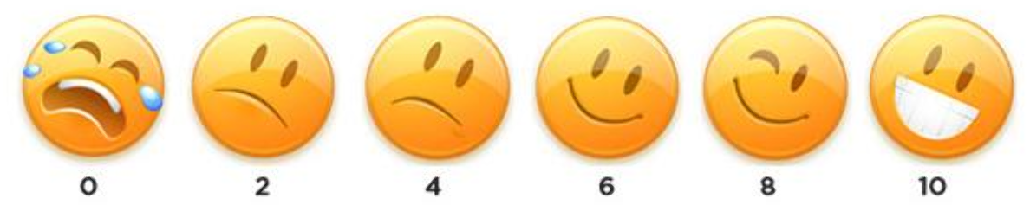
I love my family and have a great relationship!
We do have a relationship
We don’t get along!
I love my family, even thru our little disagreements.

Confusion Scale
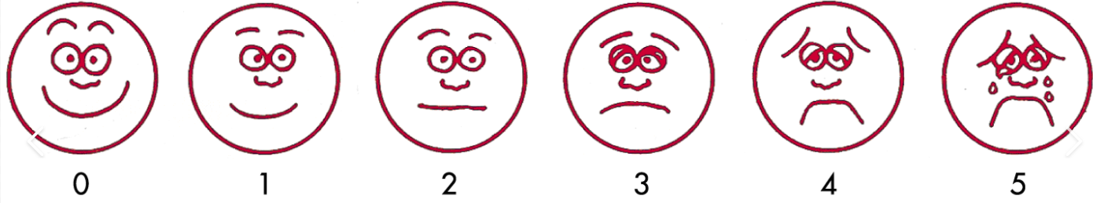
My confusion doesn’t bother me.
I get confused sometimes, but its ok.
I’m confused too much and I do like it.
I’m growing but can use some help God is my BFF
Believer.

My confusion disrupts my day.
I’m confused all the time.
No Confusion
I’m growing but can use some help God is my BFF
Believer.

